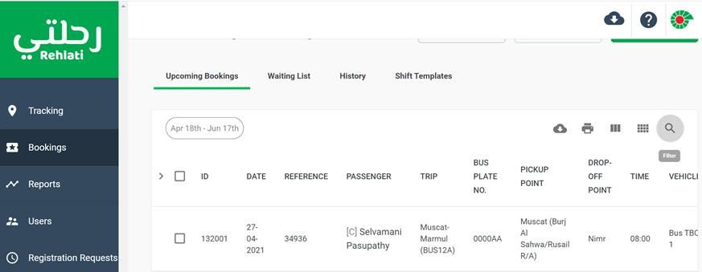

**Samira Al Balushi**

**Secretary/ Oman**  
E-mail [samira.al.balushi@dnvgl.com](mailto:samira.al.balushi@dnvgl.com)  
Direct +968 24502251

[www.dnvgl.com](http://www.dnvgl.com/)  |  LinkedIn

*Al-Nahda Tower-2 Third Floor – P.O Box:1632; P.C:112 Rwui*

*Building No.220/1  Plot No. 284 – Office No.10  Ghala; Busher – Sultanate of Oman – Muscat*